**Mini-Project Proposal**

To: Professor Dorr

From: Ali Alqaoud (819772571), Jose Baez (821513960), Abigail Dabu (820290231), Daniel Kenner (822928477), Elias Wooten (820407309)

Subject: Mini-Project Proposal – COMPE/EE-496A

Date: September 11, 2020

**Summary**

We propose to build a circuit that starts a fan when the temperature of a sensor passes a threshold and increases the brightness of an LED as the temperature increases. The title of our project is “Pointless Fan”. This project will be engineered to satisfy the Mini-Project requirement for COMPE/EE 496A.

**Project Description and Block Diagram**

A block diagram for the circuit is shown in Figure 1. Power is provided from a +12 V power supply via *connector* on the Printed Circuit Board (PCB). A voltage buffer is connected to a temperature gauge that drives a LED output. The purpose of this connection is so that the LED brightness increases as the temperature gauge heats up. The voltage buffer allows for a visual output of the temperature gauge without affecting the overall output. The comparator acts as a logic system. When the voltage of the temperature gauge is equal or greater to the voltage set by the potentiometer it generates a voltage at the mosfet gate. This allows for current to flow through the fan, causing the fan to spin. The circuit will be constructed on a Printed Circuit Board (PCB) with approximate dimensions 2” by 4”. Mounting holes will be located at the corners of the board, 0.25” from each edge. The mounting holes will be connected to ground, and have clearance for a number 6 screw. Through-hole components will be used.

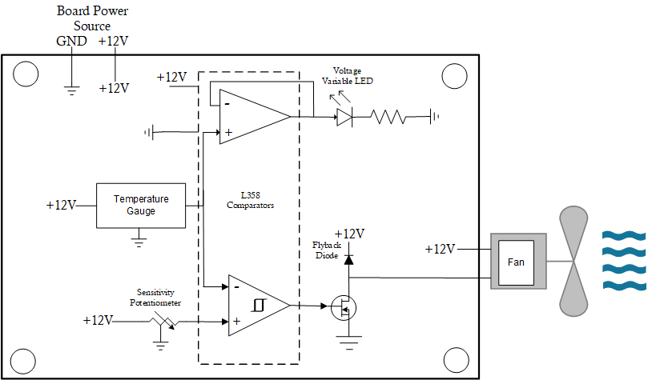

*Figure 1 - Pointless Fan Project - Block Diagram*

**Specifications and Validation**

|  |  |  |
| --- | --- | --- |
| ID | Specification | Validation |
| 1 | Temperature sensor circuit has a voltage change of 1.5V.  <2.3V across the thermistor to ground at minimum temperature and >3.8V across the thermistor to ground at maximum temperature. | Vary thermistor temperature with a heat gun and use a multimeter to measure the voltage across the temperature sensor at a minimum temperature (room temperature, 75°F) and maximum temperature (200°F ± 20**°**F). Then, subtract the voltages to find the range of voltage change. |
| 2 | Comparator outputs <0.7V until the temperature sensor is greater than 200°F ± 20**°**F. After which Comparator outputs >9.5V. | Vary thermistor temperature from initial room temperature (minimum = 65°F, maximum = 95°F) to turn-ON temperature (minimum = 180°F, maximum = 220°F)  with a heat gun set to 680°F pointing to the thermistor at a distance of <0.5 inches.  Use a multimeter to measure comparator output voltage. Comparator output logic HIGH when >9.5V. |
| 3 | MOSFET triggers (Drain voltage < 0.5V) when the comparator sends a logic HIGH (10V). | Measure voltage at output of comparator. When the comparator shows a logic HIGH (10V on output), the MOSFET shall have <0.5V on the drain. |
| 4 | LED varies from 0% brightness at room temperature to >95% power at comparator logic HIGH. | Inspect circuit while heating temperature sensor:  LED must be off initially at room temperature (minimum = 65°F, maximum 95°F)  LED must be at maximum brightness (as gauged by visual inspection) at fan turn on as described in ID 5. |
| 5 | Fan spins when the MOSFET has less than <0.5V across the drain to ground. | Verify that the fan spins by visual inspection when MOSFET voltage drop from drain to ground is <0.5V. |

**Satisfaction of Course Requirements**

|  |  |
| --- | --- |
| Requirement | How Met |
| Must be done in groups of five. | Our group consists of five students. |
| Must perform a testable operation as described in the proposal. | Using a multimeter and observing the fan and the LED, we can probe the PCB at certain stages. The stages of interest are as follows: When we first turn on the circuit, when the fan has yet to turn on, and after the fan has turned on. |
| Must have an analog component such as a transistor, MOSFET, or op-amp. | Our circuit uses an IRF830 MOSFET. |
| Must have a digital IC that performs a simple function. | Our circuit uses an LM358 comparator. |
| Must have at least one PCB connector. | One molex connector will be used for the fan which connects to two exposed looped wires. These wres will also be used to supply power to the PCB (to clip onto with alligator clips). |
| Must have four mounting holes in a rectangle. | Mounting holes will be located at the corners of the board, 0.25” from each edge. |
| Parts budget limited to $15.00. | Aggregate cost is $6.28. See breakdown below. |

**Team Skill Assessment**

|  |  |
| --- | --- |
| Skill or System Component | Implementation |
| Flyback Diode | Done as part of EE 310 and covered in application notes and mentioned in senior design class. |
| Hysteresis of comparator | Done as part of EE 310. |
| MOSFET logic | Done as part of COMPE 270 as a non-inverting amplifier. |
| Schematic Capture | Team members will learn KiCad. |
| PCB Design | Team members will learn KiCad. |
| PCB Fabrication | SDSU Milling facility used. |
| Install components on PCB | Done as part of EE330 lab. |

**Cost**

|  |  |  |  |  |  |
| --- | --- | --- | --- | --- | --- |
| Quantity | Description | MFG P/N | DigiKey | Cost (1 pc) | Ext |
| 1 | Comparator | LM358P | 296-1395-5-ND | $0.36 | $0.36 |
| 1 | N-FET | IRFU420APBF | IRFU420APBF-ND | $1.50 | $1.50 |
| 1 | Thermistor | TFPTL15L2200FL2B | 541-1428-ND | $1.58 | $1.58 |
| 1 | 10k pot | PT10MH01-103A2020-S | PT10MH01-103A2020-S | $0.47 | $0.47 |
| 2 | 3.3v LED | LTW-420D7 | LED WHITE CLEAR T-1 T/H | $0.54 | $1.08 |
| 1 | 220k resistor | CF14JT220K | CF14JT220KTR-ND | $0.01 | $0.01 |
| 1 | 510k resistor | CF14JT510R | CF14JT510RCT-ND | $0.01 | $0.01 |
| 1 | Fan | FAD1-04010BSAW11 | FAD1-04010BSAW11-ND | $1.27 | $1.27 |
|  |  |  |  | **Total** | **$6.28** |

**Customer Sign-Off Sheet**

**Team Members:** Ali Alqaoud, Jose Baez, Abigail Dabu, Daniel Kenner, Elias Wooten

**Project Title:** Pointless Fan

**Satisfaction of Technical Requirements**

|  |  |  |  |
| --- | --- | --- | --- |
| ID | Specification | Validation | Initial |
| 1 | Temperature sensor circuit has a voltage change of 1.5V.  <2.3V across the thermistor to ground at minimum temperature and >3.8V across the thermistor to ground at maximum temperature. | Vary thermistor temperature with a heat gun and use a multimeter to measure the voltage across the temperature sensor at a minimum temperature (room temperature, 75°F) and maximum temperature (200°F ± 20**°**F). Then, subtract the voltages to find the range of voltage change. |  |
| 2 | Comparator outputs <0.7V until the temperature sensor is greater than 200°F ± 20**°**F. After which Comparator outputs >9.5V. | Vary thermistor temperature from initial room temperature (minimum = 65°F, maximum = 95°F) to turn-ON temperature (minimum = 180°F, maximum = 220°F)  with a heat gun set to 680°F pointing to the thermistor at a distance of <0.5 inches.  Use a multimeter to measure comparator output voltage. Comparator output logic HIGH when >9.5V. |  |
| 3 | MOSFET triggers (Drain voltage < 0.5V) when the comparator sends a logic HIGH (10V). | Measure voltage at output of comparator. When the comparator shows a logic HIGH (10V on output), the MOSFET shall have <0.5V on the drain. |  |
| 4 | LED varies from 0% brightness at room temperature to >95% power at comparator logic HIGH. | Inspect circuit while heating temperature sensor:  LED must be off initially at room temperature (minimum = 65°F, maximum 95°F)  LED must be at maximum brightness (as gauged by visual inspection) at fan turn on as described in ID 5. |  |
| 5 | Fan spins when the MOSFET has less than <0.5V across the drain to ground. | Verify that the fan spins by visual inspection when MOSFET voltage drop from drain to ground is <0.5V. |  |

**Satisfaction of Course Requirements**

|  |  |  |
| --- | --- | --- |
| Requirement | How Met | Initial |
| Must be done in groups of five. | Our group consists of five students. |  |
| Must perform a testable operation as described in the proposal. | Using a multimeter and observing the fan and the LED, we can probe the PCB at certain stages. The stages of interest are as follows: When we first turn on the circuit, when the fan has yet to turn on, and after the fan has turned on. |  |
| Must have an analog component such as a transistor, MOSFET, or op-amp. | Our circuit uses an IRF830 MOSFET. |  |
| Must have a digital IC that performs a simple function. | Our circuit uses an LM358 comparator. |  |
| Must have at least one PCB connector. | Two connectors will be used. One molex connector will be used for the fan and two exposed looped wires will be used to supply power to the PCB (to clip onto with alligator clips). |  |
| Must have four mounting holes in a rectangle. | Mounting holes will be located at the corners of the board, 0.25” from each edge. |  |
| Parts budget limited to $15.00. | Aggregate cost is $6.28. See breakdown below. |  |

|  |
| --- |
| **This project has been successfully demonstrated and meets or exceeds all specifications**  Signature __________________________ Team: __________________ Date: __________________ |